|  |  |  |  |
| --- | --- | --- | --- |
| **Instructor** |  | **Due Date** |  |

**Review of HTML Web Page Design ( 100 points )**

**PROJECT ONE - Review of HTML Web Page Design**

***PROJECT DESCRIPTION***

Create a Web page using Notepad , according to the following instructions.

***Information about This Project***

A Web page is easily designed using the HTML editor included within Notepad .

***Steps to Complete This Project***

**STEP 1**  **Open Notepad on Your Computer**

Launch Notepad . Open a **New File** by clicking New from the File .

menu and then choosing File ... . When the **New File** dialog box appears, click **General**, under the Categories section, select the **Text File** template and then click Open to close the dialog box.

Notepad now creates a default text file usually named **TextFile1** and

opens the file for you, ready for designing. Save the text file as a Web page file by clicking File on the main menu and selecting Save TextFile1 As … . When the **Save File As** dialog box opens, click the Up One Level icon repeatedly until you reach the Desktop, then click the Create New Folder icon and create a folder named **WebFiles**. Open the new folder and save the file as **MyPage.htm** to the new folder on your Desktop.

Click Save to close the **Save File As** dialog box.

**STEP 2**  **Design the Required Web Page**

Begin typing the lines of HTML code / tags listed below. You will notice that as you write the code within Notepad, that standard HTML tags are displayed in a red font color. Replace your own name in place of Sammy Student.

**Figure 1 HTML Source Code**

|  |
| --- |
|  |

|  |
| --- |
| <html>  <!-- Sammy Student: Web Programmer -->  <head>  <title>Welcome</title>  </head>  <body bgColor = "LightSkyBlue">  <font face = "Tahoma">  <h1 align = "center">Addison Antiques</h1>  </body>  </html> |

|  |
| --- |
|  |

After you end your Web page code by typing the closing </html> tag, save your completed Web page.

**PROJECT ONE**

**STEP 3 Preview Your Web Page**

Preview your Web page to ensure that your HTML source code correctly displays the page. To do this, leave Notepad open and navigate to your computer’s Desktop. Locate the Web page entitled **MyPage.htm** within the **WebFiles** folder on your Desktop and double - click the file to view it in your Web browser.

Your Web page now appears within Internet Explorer, as shown below.

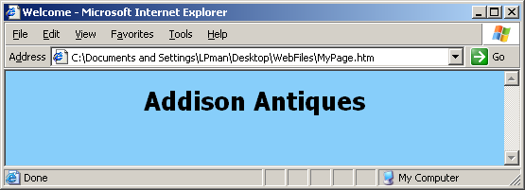

View the page and return to Notepad .

**STEP 4 Modify Your Web Page**

Once you have verified that your Web page is displayed properly within your Web browser, return to Notepad and modify your Web page by adding the HTML code shown within the comments statements below.

**Figure 2 HTML Source Code**

|  |
| --- |
|  |

|  |
| --- |
| <html>  <!-- Sammy Student: Web Programmer -->  <head>  <title>Welcome</title>  </head>  <body bgColor = "LightSkyBlue">  <font face = "Tahoma">  <h1 align = "center">Addison Antiques</h1>  <!-- comment: begin new HTML code -->  <br>  <hr>  <p></p>  <h2>we stock a complete line of . . .</h2>  <ul>  <li>Collectibles  <li>Gift items  <li>Arts and Crafts supplies  <li>Rare antiques  <li>and more...  </ul>  <!-- comment: end new HTML code -->  </body>  </html> |

|  |
| --- |
|  |

**PROJECT ONE**

The supplemental new code is to be inserted just before the closing </body>

tag. Note these HTML tags are not case sensitive.

After you type the additional HTML code, save your completed Web page.

**STEP 5 Preview Your Modified Web Page**

Preview your Web page to ensure that your HTML source code correctly displays the page. To do this, leave Notepad open and navigate to your computer’s Desktop. Locate the Web page entitled **myPage.htm** within the **WebFiles** folder on your Desktop and double - click the file to view it in your Web browser.

Your Web page now appears within Internet Explorer, as shown below.

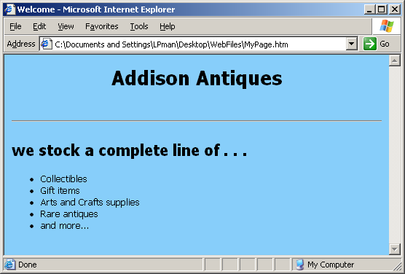

If your Web page works properly, you should view the above screen. If not return to Notepad, review the program code given within **Figure 2** and

check if your code corresponds to it. Make any necessary corrections and re - load your page within Internet Explorer.

After viewing your Web page, close Internet Explorer.

**STEP 6 Add Special Effects to the Web Page and Change the Text Colors**

Return to Notepad and add a scrolling marquee to the body text of the

Web page. To do this, locate the following statement.

<h2>we stock a complete line of. . .</h2>

Type opening <marquee> and closing </marquee> tags around the above statement to arrive at the line of code given below.

|  |
| --- |
| <marquee><h2>we stock a complete line of. . .</h2></marquee> |

**PROJECT ONE**

After you type the additional HTML code, save your completed Web page.

Navigate again to your Desktop, locate the Web page entitled **myPage.htm** within the **WebFiles** and double - click the file to preview the page.

Observe the scrolling marquee effect on the body text.

Close Internet Explorer and return again to Notepad.

Add special text colors to the unordered list elements. To do this, first locate the following line of Web code:

<li>gifts

Type opening <FONT> and closing </FONT> tags around the word " gifts " in the above statement to arrive at the line of code given below, using the given color.

<li><font color = "blue">Collectibles</font>

Do this for each of the list items. Add color to the text words according to this chart.

|  |  |
| --- | --- |
| **list item** | **text color** |
|  |  |
| Collectibles | Blue |
| Gift items | Red |
| Arts and Crafts supplies | Green |
| Rare antiques | BlueViolet |
| and more . . . | Gold |

After you type the additional HTML code, save your Web page.

Open the Web page in Internet Explorer.

Observe the scrolling marquee effect on the body text and the different colors of the list items.

Close Internet Explorer and return again to Notepad.

**STEP 7 Save Your Code and Close Notepad**

Returning to Notepad, keep Notepad open if you intend to start now the next lab project.

**PROJECT TWO - Introduction to Web Programming**

***PROJECT DESCRIPTION***

Using Notepad , create an HTML page that involves Web programming.

***Information About This Project***

Web programming is easy using Notepad .

***Steps to Complete This Project***

**STEP 1**  **Open Notepad on Your Computer**

If it is not already open, launch Notepad . Open a **New File** by clicking New from the File menu and then choosing File ... . When the **New File** dialog box appears, click **General**, under the Categories section, select the **Text File** template and then click Open to close the dialog box.

Notepad now creates a default text file named **TextFile** followed

by a number and opens the file for you, ready for designing. Save the text

file as a Web page file by clicking File on the main menu and selecting

. Save TextFile2 As … (assuming that the file is called **TextFile2** ). When

the **Save File As** dialog box opens, save the file as **MyPage2.htm** to the **WebFiles** folder on your Desktop, that you created in the prior project.

Click Save to close the **Save File As** dialog box.

**STEP 2**  **Design the Required Web Page**

Begin typing the lines of HTML code / tags listed in **Figure 2** , which follows.

Use your own name in place of Sammy Student.

The code produces the Web page given below.

**Figure 1**

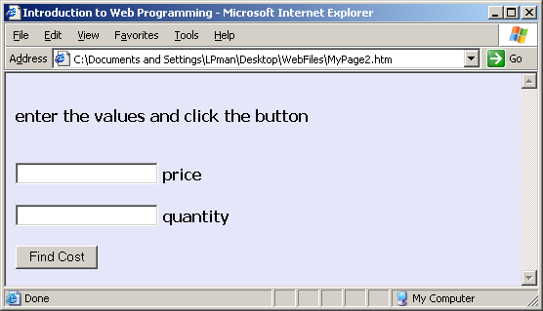

**PROJECT TWO**

Here is the code for this project. Type the code exactly as it appears, except insert your own name in place of Sammy Student.

After typing your HTML code, save your file.

**Figure 2 HTML Source Code**

|  |
| --- |
|  |

|  |
| --- |
| <html>  <!-- Sammy Student: Web Programmer -->  <head>  <title>Introduction to Web Programming</title>  </head>  <body bgColor = "Lavender">  <font face = "Tahoma" size = "5">  <b>  <br>  <h2>enter the values and click the button</h2>  <br>  <form name = "Form1">  <input type = "text" name = "one">&nbsp;price  <br><br>  <input type = "text" name = "two">&nbsp;quantity  <br><br>  <input type = "button" value = "Find Cost"  onClick = 'var cost = (one.value * two.value);  window.alert("the cost is $" + cost);'>  </b>  </form>  </body>  </html> |

|  |
| --- |
|  |

**STEP 3 Open Internet Explorer and Preview Your Web Page**

Open the Web browser known as Internet Explorer.

To view your page in Internet Explorer, navigate to the File menu and choose

. Open… . Browse for the location of the file **MyPage2.htm** and click OK .

Your Web page should now open in Internet Explorer.

If your Web page works properly, you should view the screen snapshot given within **Figure 1** . If not, return to Notepad, review your code and make any necessary corrections. Save the corrections and re - load the page.

With your page displaying the information correctly, enter a number into each of the textboxes and click the button. An alert() message box then appears displaying the product of the two numbers.

Close the alert message box and keep your Web page open in Internet Explorer.

**STEP 4 Modify Your Web Page**

Click View on the Internet Explorer menu bar and select Source . Notepad opens, showing your code.

**PROJECT TWO**

Modify your code in Notepad such that the Web page user can enter three numbers, a price a quantity and a discount and click a button to display the product of the price and the quantity reduced by the discount amount.

Save your modified HTML source code in Notepad, close Notepad, return to your open Web page in Internet Explorer and press F5 to refresh your browser and load your new page.

After your page loads, your Web page should appear as that shown in the screen snapshot below.

**Figure 3**

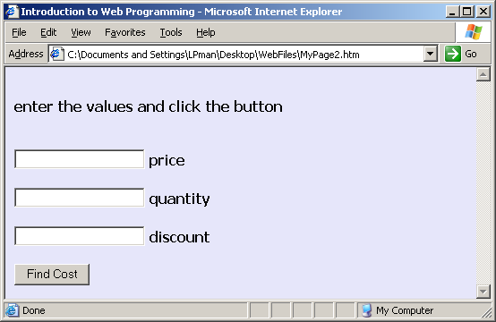

With your page displaying the information correctly, enter a number into each of the three textboxes and click the button. An alert message box should then appear displaying the product of the three numbers.

Close the alert() message box.

Click View on the Internet Explorer menu bar and select Source . Notepad again opens, showing your code.

For the next modification, you will add a condition to the button <input> tag such that if the cost is greater than 100 , a message will appear instead of the actual product.

To do this, you will alter the code in the <input> tag such that the onClick event will be in the form:

|  |
| --- |
| <input type = "button" value = "Find Cost"  onClick = 'var cost = one.value * two.value - three.value;  var result = (cost > 100) ? "more than $ 100" : "$ " + cost; window.alert("the cost is " + result);'> |

Note that the code assumes that the new text field that you added earlier has its name attribute set to three .

**PROJECT TWO**

Remember that the code with the onClick event is case sensitive.

The code within the event makes use of a conditional expression operation. The syntax of this operation is:

( *condition* ? value1: value2 )

The value of the operation is value1 if the condition is true and value2 if the condition is false.

For example, the expression

( a > b ? a : b )

equals 5 if a is 5 and b is 2 .

**STEP 5 Run Your Modified Web Page**

Save your modified code and close Notepad. Return to your Web page which is visible in the Web browser. On the Internet Explorer click View on the Internet Explorer menu bar and select Refresh to re - load the Web page.

With your page displaying the information correctly, enter a number into each of the textboxes. Choose numbers such that the product will be 100 or less. Then click the button. A message box such as shown below appears.

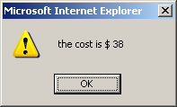

Take a screen snapshot of the alert() message box by clicking on the Title bar of the message box, pressing and hold your keyboard Alt key and then pressing your Print Screen key. Then, leaving your Web document open, paste the screen snapshot into MS Word by opening Word and, in a new document, pressing and holding your Ctrl key and then pressing your V key.

Return to your Web page in Internet Explorer and enter a number into each of the textboxes. Choose numbers such that the product will be more than 100 . Then click the button. A message box such as shown below appears.

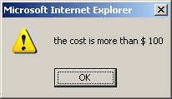

Paste the screen snapshot in your MS Word document. Below your screen snapshot in your Word document, press your Enter key a few times and then type your name, the course number and date. Finally, submit the code and

snapshots of the results for credit.

Return to Notepad and, on the main menu, click File and then click

. Close Solution . Keep Notepad open to start the next lab project.

**PROJECT THREE - Review of HTML Table Design**

**Objective** To build a Web page using HTML table tags and Notepad .

***PROJECT DESCRIPTION***

Tables are used in a Web page to make data easier to view and interpret or just to

give your document more impact. This project has you using Notepad and HTML code to design a Web page which contains a table. The table consists of data corresponding to a company’s sales revenue by division.

***Information About This Project***

Tables are challenging to code with HTML. Creating a table starts with using

the <table> . . . </table> tag pair. Together with the <table> tag, the

<tr> . . . </tr> tag pair is used to create a row and the <td> . . . </td> tag

is used to create a column.

***Steps To Complete This Project***

**STEP 1**  **Open Notepad on Your Computer**

If it is not yet open, launch Notepad . Open a **New File** by clicking

. New from the File .menu and then choosing File ... . When the **New File** dialog box appears, click **General**, under the Categories section, select the **HTML Page** template and then click Open to close the dialog box.

Notepad now creates a default HTML Web page named **HTMLPage1**

and opens the file in the Design view. Rename the Web page file by clicking

. File on the main menu and selecting Save HTMLPage1 As … . When the **Save File As** dialog box opens, save the file as **MyTable** to your **WebFiles** folder on your Desktop.

Click Save to close the **Save File As** dialog box.

**STEP 2**  **Design the Required Web Page**

With your HTML page open in the Design view, click the HTML tab that appears in the lower left corner.



This takes you to the HTML view of your Web document and places your cursor within the <body> of the Web document.

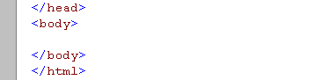

Within the <body> . . . </body> section of the Web page, type the lines of HTML code shown in **Figure 1** , which follows. Insert your own name where you see Sammy Student in the HTML code.

After typing your HTML code, save your file.

**PROJECT THREE**

**Figure 1 HTML Source Code**

|  |
| --- |
|  |

|  |
| --- |
| <!-- Sammy Student: HTML Table Project -->  <FONT face = "Tahoma">  <DIV align = "center">  <H1>The Higgins Corporation</H1>  <br>  <H2>Sales by Division</H2>  <table>  <tr>  <td width = "100">Chicago</td>  <td width = "100">$6,500</td>  </tr>    <tr>  <td width = "100">Detroit</td>  <td width = "100">$2,500</td>  </tr>  </table>  </DIV>  </FONT> |

|  |
| --- |
|  |

**STEP 3 Open Internet Explorer and Preview Your Web Page**

Open the Web browser known as Internet Explorer.

To view your page in Internet Explorer, navigate to the File menu and choose

. Open… . Browse for the location of the file **MyTable.htm** and click OK .

Your Web page should now open in Internet Explorer. Note: if you are loading the Web page from a network computer, you may have to, instead of the above procedure, navigate to Windows Explorer, locate your file and double - click the file to open the file in a Web browser.

If your Web page works properly, you should view a tabular array of financial data. If not return to Notepad, review the program code given within

**Figure 1** and check if your code corresponds to it. Make any necessary corrections.

With your table correctly visible, keep Internet Explorer open.

**STEP 4 Modify Your Web Page**

Return now to Notepad and modify your Web page by adding a new row of information. Add a new table row and place the row just below the Detroit sales figures. The new row is to contain the sales amount for Milwaukee. The Milwaukee division sales are $ 1,800 .

Save your modified HTML source code and refresh your browser to load your new page. After your page loads, your resulting tabular array should now contain sales data for three cities in a professional row by column format.

**STEP 5 Submit Code and Snapshot of Your Web Page**

Copy the code and submit it and a snapshot of the output for credit.

**PROJECT FOUR - Review of HTML Check Box Controls**

**Objective** To build a Web page using HTML check boxes.

***PROJECT DESCRIPTION***

This project has you designing a Web page using Notepad and HTML code and

then viewing the page using Internet Explorer. The Web page consists of a series of check boxes.

***Information About This Project***

Check boxes differ from radio buttons in that there are not mutually exclusive, when there are selected. That is, none, one or more than one check box can be selected simultaneously.

***Steps To Complete This Project***

**STEP 1**  **Open Notepad on Your Computer**

If it is not yet open on your computer, launch Notepad . Open a **New File** by clicking New from the File .menu and then choosing File ... . When the **New File** dialog box appears, click **General**, under the Categories section, select the **HTML Page** template and then click Open to close the dialog box.

Notepad now creates a default HTML Web page named **HTMLPage**

followed by a number and opens the file in the Design view. Rename the Web page by clicking File on the main menu and selecting Save HTMLPage2 As … .

( assuming that the file is called **HTMLPage2** ). When the **Save File As** dialog box opens, save the file as **check** to your **WebFiles** folder on your Desktop.

Click Save to close the **Save File As** dialog box.

**STEP 2**  **Design The Required Web Page**

You will now type the code of an HTML Web page that displays a series of check boxes and allows the user to select from a series of check boxes and to click a button to display a message.

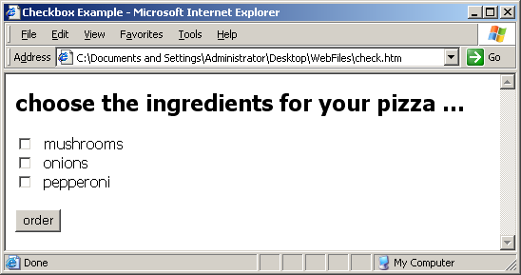

**PROJECT FOUR**

With your HTML page open in the Design view, click the HTML tab that appears in the lower left corner.



This takes you to the HTML view of your Web document and places your cursor in the <body> of the Web document.

With your cursor located within the HTML Design view of the Web document,

use the keyboard shortcut Ctrl + A followed by Ctrl + X to cut any existing, skeletal source code that is automatically generated by Notepad .

Then, within the Web document, type the code shown in **Figure 1** which follows.

**Figure 1 HTML Source Code**

|  |
| --- |
|  |

|  |
| --- |
| <HTML>  <HEAD>  <TITLE>Checkbox Example</TITLE>  <SCRIPT>  function display()  {  var message = "you selected ...";  if (eval("document.pizza.one.checked") == true)  message += "\n" + "mushrooms";  if (eval("document.pizza.two.checked") == true)  message += "\n" + "onions";  if (eval("document.pizza.three.checked") == true)  message += "\n" + "pepperoni";  if (message == "you selected ...")  message = "plain cheese pizza ordered";  alert(message);  }  </SCRIPT>  </HEAD>  <BODY>  <FONT face = "Tahoma">  <H2>choose the ingredients for your pizza ...</H2>  <FORM ID = "Form1" name = "pizza">  <INPUT TYPE = "checkbox" NAME = "one">&nbsp; mushrooms<BR>  <INPUT TYPE = "checkbox" NAME = "two">&nbsp; onions<BR>  <INPUT TYPE = "checkbox" NAME = "three">&nbsp; pepperoni<BR>  <BR>  <INPUT TYPE = "button" Value = "order" onClick = "display()">  </FORM>  </FONT>  </BODY>  </HTML> |

|  |
| --- |
|  |

**PROJECT FOUR**

After typing your HTML code, save your file.

**STEP 3 Open Internet Explorer and Preview Your Web Page**

Open the Web browser known as Internet Explorer.

To view your page in Internet Explorer, navigate to the File menu and choose

Open… . Browse for the location of the file **check.htm** and click OK . Or you can navigate to the WebFiles folder on you Desktop, open the folder and double - click the file to open it in a Web browser.

You Web page should now be visible in Internet Explorer.

If your Web page works properly, you should view a heading, a series of check boxes and a button. If not, review the program code given within **Figure 1** and check if your own code corresponds to it. Make any necessary corrections.

Keep Internet Explorer open and proceed to the next step.

**STEP 4 Test Your Web Page**

Test the operation of the Web document by checking an ingredient and clicking the button. An alert() message box screen such as shown below will appear.

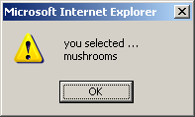

Close the message box and now try not selecting any of the ingredients and clicking the button. The default message " plain cheese pizza ordered " should appear. Close the message box and prepare to modify your Web document.

**STEP 5 Modify Your Web Page**

Return to your Notepad Web file for this project and modify the code of the file such that it allows the user to choose an additional ingredient, namely spinach. Place the new check box below the check box for pepperoni.

Save your modified Web page in Notepad and open the file in Internet Explorer. Test the operation of your modified Web page.

**STEP 6 Print the Message Box**

Select again your favorite pizza ingredients ( include spinach ) and click the button. Then take a screen snapshot of the alert message box that appears.

To do this, click on the Title bar of the message box, press and hold your keyboard Alt key and then press your Print Screen key. Then, leaving

your Web document open, paste the screen snapshot into MS Word by opening Word and, in a new document, pressing and holding your Ctrl key and then pressing your V key.

Below your screen snapshot in your Word document, press your Enter key a few times and then type your name, the course number and date. Finally, submit your code and snapshot of your web page output it for credit.

**PROJECT FIVE - Interactive HTML / JavaScript**

**Objective** To create a user - interactive HTML / JavaScript Web Page.

***PROJECT DESCRIPTION***

This project focuses on using elementary JavaScript code to have the Web page viewer interact with the underlying HTML / JavaScript source code.

***Information About This Project***

This project involves the creation of a user - interactive, Web page. The code involves the simple topic of multiplying a price by a quantity to arrive at a cost amount.

The code for this project involves requesting information form the Web page visitor via a JavaScript prompt box, which has he following general format:

prompt("your message");

To store a user’s non - numeric response to a prompt box, you can assign a variable to it as follows:

var myVariable = prompt("my message", "default message");

To store a user’s numeric response to a prompt box, you can assign a variable to it as follows:

var myNumber = parseFloat(prompt("enter the number", ""));

***Steps To Complete This Project***

**STEP 1 Open Notepad and Type the HTML / JavaScript Code**

Within Notepad , create a new HTML file. Save your Web page

as **cost.htm** . Within this file, type the HTML / JavaScript code shown in

**Figure 1** , which follows.

**Figure 1 HTML / JavaScript Source Code**

|  |
| --- |
|  |

|  |
| --- |
| <HTML>  <HEAD>  <TITLE>Cost Calculator</TITLE>  </HEAD>  <BODY>  <BR>  <H2>welcome to ... The Cost Calculator</H2>  <BR>  <SCRIPT>  var items = parseInt(prompt("enter number of items", ""));  var price = parseFloat(prompt("enter item price", ""));  document.write("<H3>" + "cost... $" + items * price + "</H3>");  document.write("<H2>" + prompt("enter a name", "") + "</H2>");  </SCRIPT>  </BODY>  </HTML> |

|  |
| --- |
|  |

**PROJECT FIVE**

**STEP 2 Open Internet Explorer and Preview Your Web Page**

Navigate to the WebFiles folder on you Desktop, open the folder and double - click the **cost.htm** file to open the file in a Web browser.

If your Web page works properly, you should view the following prompt box.

If not, review the program code given within **Figure 1** and check if your own code corresponds to it. Make any necessary corrections.

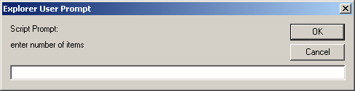

Enter the number 10 in the prompt box and click OK .

The following prompt box appears.

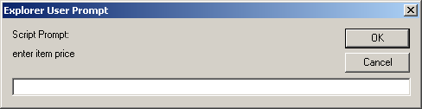

Enter the number 5.5 in the prompt box and click OK .

This statement " cost . . . $ 55 " appears in the page and the box below opens.

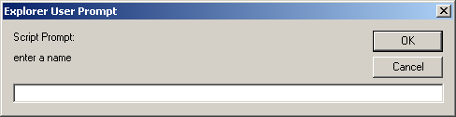

Enter your own name in the prompt box and click OK .

The following screen then appears with the results of your calculations:

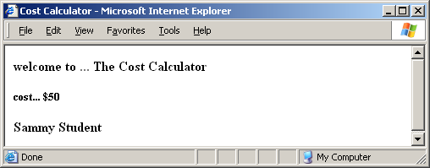

**PROJECT FIVE**

Keep Internet Explorer open and proceed to the next step.

**STEP 3 Modify Your Web Page**

Modify the **cost.htm** Web page by adding a discount of 5 % .

To do this, follow these instructions:

• Locate the following line of code.

var price = parseFloat(prompt("enter item price"));

• Just below the above line of code, insert the following statement.

var amount = items * price * (1.0 - .05);

• Locate the following statement.

|  |
| --- |
| document.write("<H3>" + "cost... $" + items * price + "</H3>"); |

• Change the above statement such that it will state:

|  |
| --- |
| document.write("<H3>" + "cost... $" + amount + "</H3>"); |

After making the modifications, save the Web document.

**STEP 4 Run Your Modified HTML / JavaScript Code**

Return to your Internet Explorer Web browser.

Press F5 to refresh the Web browser .

Type the following quantity / price values into your user - interaction Web page. Then, when prompted, type your own name. What answer do you

arrive at for your cost? The correct answer is $ 3,049.50 .

|  |  |  |
| --- | --- | --- |
|  | **number of items** | 300 |
|  | **item price** | 10.70 |

Take a screen snapshot of your Web browser showing the results of entering the above information and attach the hardcopy for credit.

To take a screen snapshot, remember to use the instructions outlined below.

With your Web page still open in Internet Explorer and visible with your calculations, press and hold your keyboard Alt key and then press your

. Print Screen key. Then, leaving your program open, paste the screen snapshot into MS Word by opening Word and, in a new document, pressing and holding your Ctrl key and then pressing your V key.

Below your screen snapshot in your Word document, press your Enter key a few times and then type your name, the course number and date. Finally, save your Word document to submit electronically for credit.

**STEP 5 Print/Copy Your JavaScript**

Next, return to Internet Explorer to print your Web page code. To do this, click

. View on the menu bar and select Source . When Notepad opens, showing

your code, highlight the code, then click Edit and then click Copy . Submit your code and snapshot of the web page output for credit.

**PROJECT SIX - Introduction to JavaScript**

**Objective** To learn the basics of JavaScript.

***PROJECT DESCRIPTION***

This project focuses on using elementary JavaScript code to show the many uses of this language.

***Information About This Project***

This project uses a JavaScript tutorial to assist you in modifying a standard Web page such that it contains JavaScript effects. JavaScript is an object - oriented, client - side scripting language which is used to make Web pages more dynamic. The general

format for a <SCRIPT> tag containing JavaScript code is:

<SCRIPT language = "JavaScript">

<!--

*place statements here*

//-->

</SCRIPT>

The code is placed within HTML <SCRIPT> statements in a Web document, in the HEAD or the BODY or both. JavaScript code is case sensitive.

***Steps To Complete This Project***

**STEP 1 Using JavaScript to Write Text**

Open a new Text file in Notepad and, within the text file, type the following script.

**Figure 1 HTML / JavaScript Source Code**

|  |
| --- |
|  |

|  |
| --- |
| <HTML>  <HEAD>  <TITLE>Using JavaScript</TITLE>  </HEAD>  <BODY>  <SCRIPT language = "JavaScript">  <!--  document.write("<FONT COLOR = 'WHITE'>");  document.write("<h1>display_message</h1>");  //enter your own message in the above statement  document.bgColor = "blue";  document.write("<\FONT>");  //-->  </SCRIPT>  </BODY>  </HTML> |

|  |
| --- |
|  |

After typing your HTML / JavaScript code in Notepad , save your text file by clicking File , then selecting Save As… and then, in the File Name: field, type the HTML filename: "jscript1.htm"

Note: type quotation marks around the file name so that Notepad will not use the default .txt extension.

**PROJECT SIX**

Now preview your Web page by opening the file in your Web browser. You should only see your own message in your page:

display_message

If your Web page appears blank, return to Notepad to check your

code, make any necessary adjustments, save the adjustments and refresh your Web browser by clicking F5 .

After verifying that your page works, click View on your Web browser menu and then click Source . Notepad opens, displaying your HTML code.

**STEP 2 Using JavaScript to Open a Browser Window**

Next, modify your Web page from **Figure 1** to include JavaScript code which will open another Web page when your page loads. With your code visible in Notepad, locate the following lines of code from your source statements:

document.write("<\FONT>");

*place the new code here*

//-->

and, between these lines, write the JavaScript code given in **Figure 2**, below.

**Figure 2 HTML / JavaScript Source Code**

|  |
| --- |
|  |

|  |
| --- |
| window.open("http://www.FYE.com", "WindowA",  "width = 500, height = 500, scrollbars = yes"); |

|  |
| --- |
|  |

Then, save your modified HTML source code in Notepad and refresh

your browser to load your new page. Observe how your page opens as well as the given URL shown within the window.open() function.

Close the pop - up Web page, click View on your Web browser menu and then click Source . Proceed to the next step.

**STEP 3 Using JavaScript to Display a Message**

Modify your current Web page again but, this time include JavaScript code which will display a message to the viewer. Locate the following lines of code from your source code:

<!--

*place the new code here*

document.write("<FONT COLOR = 'WHITE'>");

and, between these lines, write the JavaScript code given in **Figure 3**, below.

**Figure 3 HTML / JavaScript Source Code**

|  |
| --- |
|  |

|  |
| --- |
| function display_message()  {  window.alert("Click Here To Continue");  }  display_message(); |

|  |
| --- |
|  |

**PROJECT SIX**

Then, save your modified HTML source code in Notepad and refresh your browser to load your new page. After your page loads, the message below should appear.

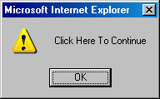

Click OK to then display your actual Web page. The pop - up window will again open. Close the pop - up window, click View on your Web browser

menu and then click Source . Proceed to the next step.

**STEP 4 Using JavaScript to View the URL of the Current Document**

Modify again your current Web page again but, this time; include JavaScript code which will display the URL of the current document. Locate the following lines of code from your source code:

"width = 500, height = 500, scrollbars = yes");

*place the new code here*

//-->

and, between these lines, write the JavaScript code given in **Figure 4**, below.

**Figure 4 HTML / JavaScript Source Code**

|  |
| --- |
|  |

|  |
| --- |
| document.write("the URL for this page is " + document.URL); |

|  |
| --- |
|  |

Save your new HTML source code in both Notepad and Notepad and refresh your browser to load the new page. After clicking the OK button of the window alert, observe how your page displays the file URL of the current document.

**STEP 5 Using JavaScript to Display the Local Date and Time**

Modify again your current Web page again but this time include JavaScript code which will display the local date and time. Just before the closing JavaScript comment line,

*place the new code here*

//-->

write the JavaScript code given in **Figure 5**, below.

**Figure 5 HTML / JavaScript Source Code**

|  |
| --- |
|  |

|  |
| --- |
| theDate = new Date();  document.write("local time: " + theDate.toLocaleString()); |

|  |
| --- |
|  |

Save your new HTML source code in Notepad and refresh your

browser to load your new page. After clicking the OK button of the window alert, observe how your page displays your computer’s date and time.

**PROJECT SIX**

**STEP 6 Add a Close Button to Your Page**

Modify again your current Web page again but this time include regular HTML code which will display a Close button on your document. Just after the closing SCRIPT statement,

</SCRIPT>

*place the new code here*

</BODY>

write the HTML code given in **Figure 6**, below

**Figure 6 HTML Source Code**

|  |
| --- |
|  |

|  |
| --- |
| <form>  <input type = "button" value = "Close" onClick = "window.close();">  </form> |

|  |
| --- |
|  |

Save your new HTML source code in Notepad and refresh your

browser to load your new page. After clicking the OK button of the window alert , click the Close button to test its operation.

**STEP 7 Print/Copy Your HTML Source Code and Screen Snapshot of Output**

Finally, submit your completed HTML / JavaScript source code for this project and submit the snapshot of the resulting web output for credit. Be sure to enter your own name, date and pertinent course information on your electronic copy for submittal.

Close your Notepad Solution.